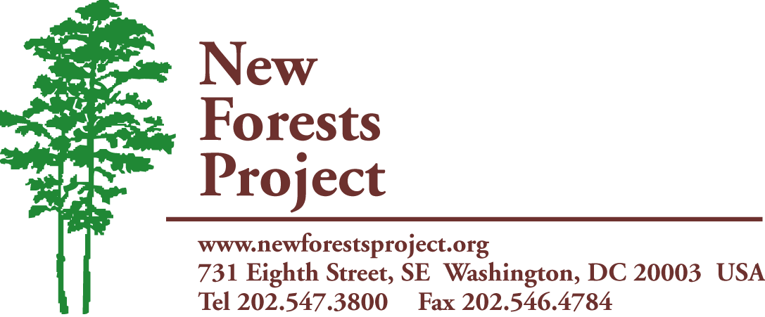
A Project of The International Center
www.newforestsproject.org

NEW FORESTS PROJECT UPDATE
December 2013

Small Grants Program


In the second half of 2013 NFP sent out a mini-proposal to our biggest donors to raise funds for our Small Grants Program. This year we have chosen to highlight the work of Zimconserve Agroforestry Center in Seke, Zimbabwe. For only $10, Zimconserve creates a more efficient cookstove which uses 66% less wood, produces less smoke, and has a contained fire. This means the seed ships NFP sends will last longer and women and children in Zimbabwe will inhale less smoke resulting in fewer smoke-related illnesses and will be less likely to endure serious burns. Zimconserve was pleased to be included in our Small Grant Program and hope to be included again in our next seed shipment.

Tree Seeds

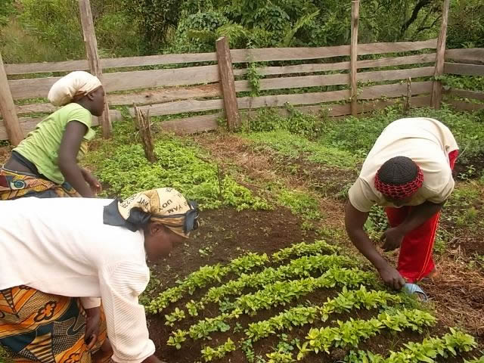
In December, several of our Tree Seed recipients submitted reports detailing their progress with seed planting and training. Nature-Care-Cameroon used their seeds in three different communities to improve agroforestry practices and reforestation among small farmers in the Kumbo Watershed. Reforestation was a major focus for N-Care but they also created an apiary and orchards as well as gave demonstrations and gave seeds away for timber, fuel, and soil improvement. AKV in Haiti disturbed their seeds to several organizations within Haiti for mostly reforestation efforts and the creation of a couple orchards. Zimconserve used their seeds for fuel, reforestation, timber, and fruit while making an effort to reverse forest loss and environmental degradation. Of the three organizations mentioned, over 10,500 trees were grown, directly affecting the lives of over 1,000 people and indirectly helping thousands more.

For more information contact:
Lysette House
Email: lhouse@theintlcenter.org
Phone: 202-285-4328

